**Implementing Dependency Injection**

**CODE:**

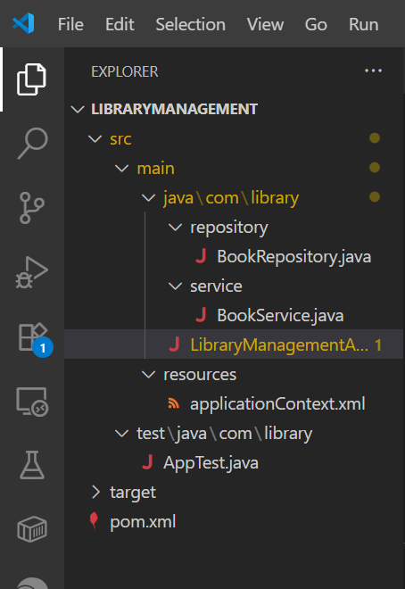

applicationContext.xml :

<?xml version="1.0" encoding="UTF-8"?>

<beans xmlns="http://www.springframework.org/schema/beans"

xmlns:xsi="http://www.w3.org/2001/XMLSchema-instance"

xsi:schemaLocation="

http://www.springframework.org/schema/beans

https://www.springframework.org/schema/beans/spring-beans.xsd">

<bean id="bookRepository" class="com.library.repository.BookRepository"/>

<bean id="bookService" class="com.library.service.BookService">

<property name="bookRepository" ref="bookRepository"/>

</bean>

</beans>

LibraryManagementApplication.java :

package com.library;

import org.springframework.context.ApplicationContext;

import org.springframework.context.support.ClassPathXmlApplicationContext;

import com.library.service.BookService;

public class LibraryManagementApplication {

public static void main(String[] args) {

ApplicationContext context = new ClassPathXmlApplicationContext("applicationContext.xml");

BookService bookService = context.getBean("bookService", BookService.class);

bookService.issueBook("Effective Java");

}

}

BookService.java :

package com.library.service;

import com.library.repository.BookRepository;

public class BookService {

private BookRepository bookRepository;

public void setBookRepository(BookRepository bookRepository) {

this.bookRepository = bookRepository;

}

public void issueBook(String bookName) {

System.out.println("Issuing book: " + bookName);

bookRepository.save(bookName);

}

}

BookRepository.java

package com.library.repository;

public class BookRepository {

public void save(String bookName) {

System.out.println("Book saved: " + bookName);

}

}

pom.xml :

<?xml version="1.0" encoding="UTF-8"?>

<project xmlns="http://maven.apache.org/POM/4.0.0"

xmlns:xsi="http://www.w3.org/2001/XMLSchema-instance"

xsi:schemaLocation="http://maven.apache.org/POM/4.0.0

http://maven.apache.org/xsd/maven-4.0.0.xsd">

<modelVersion>4.0.0</modelVersion>

<groupId>com.library</groupId>

<artifactId>librarymanagement</artifactId>

<version>1.0</version>

<packaging>jar</packaging>

<name>Library Management</name>

<properties>

<project.build.sourceEncoding>UTF-8</project.build.sourceEncoding>

<maven.compiler.source>1.8</maven.compiler.source>

<maven.compiler.target>1.8</maven.compiler.target>

</properties>

<dependencies>

<dependency>

<groupId>org.springframework</groupId>

<artifactId>spring-context</artifactId>

<version>5.3.30</version>

</dependency>

<dependency>

<groupId>junit</groupId>

<artifactId>junit</artifactId>

<version>4.11</version>

<scope>test</scope>

</dependency>

</dependencies>

<build>

<plugins>

<plugin>

<artifactId>maven-compiler-plugin</artifactId>

<version>3.8.0</version>

<configuration>

<source>1.8</source>

<target>1.8</target>

</configuration>

</plugin>

<plugin>

<groupId>org.codehaus.mojo</groupId>

<artifactId>exec-maven-plugin</artifactId>

<version>3.1.0</version>

<configuration>

<mainClass>com.library.LibraryManagementApplication</mainClass>

</configuration>

</plugin>

</plugins>

</build>

</project>

## **Output :**

